Tutorial 4 – Functional & Non-Functional Testing
Screenshot Report
Field | Details
Website / Tool | Automation Exercise
URL | https://automationexercise.com
Module | Login
Student Task | Test the Login functionality with 7 functional and 3 non-functional test cases.
Test Cases | Same TC IDs as the test case sheet: TC01 to TC10
Tester Name | Tester: Kothari Mann Jitendrakumar
Enrollment No | 2504030100433
Environment | Windows 10/11, Google Chrome (latest), internet connection

Test Case Execution

TC01 – Verify valid login
TC ID | TC01
Test Case | Verify valid login
Test Data | Email: <registered email>; Password: Test@1234
Expected Result | User logs in and 'Logged in as <name>' is shown
Actual Result | Logged in successfully
Status | PASS
Screenshot | 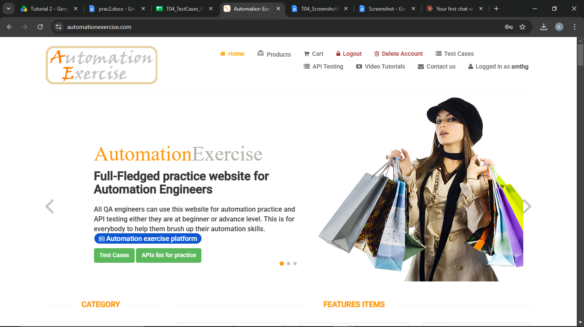
Defect ID

TC02 – Verify login with an invalid email
TC ID | TC02
Test Case | Verify login with an invalid email
Test Data | Email: wrong.user@example.com; Password: Test@1234
Expected Result | Error 'Your email or password is incorrect!' is displayed
Actual Result | Error message displayed
Status | PASS
Screenshot | 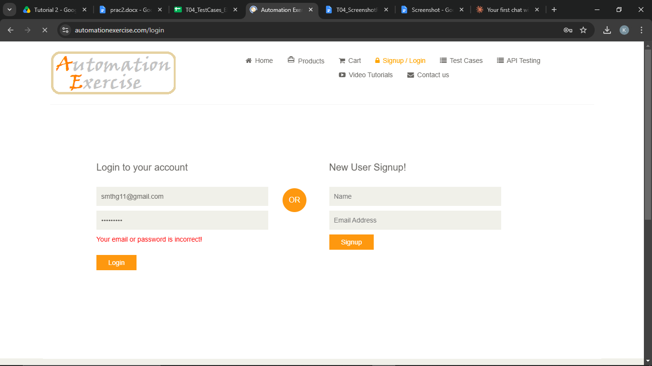
Defect ID | N/A

TC03 – Verify login with an invalid password
TC ID | TC03
Test Case | Verify login with an invalid password
Test Data | Email: <registered email>; Password: Wrong@123
Expected Result | Error 'Your email or password is incorrect!' is displayed
Actual Result | Error message displayed
Status | PASS
Screenshot | 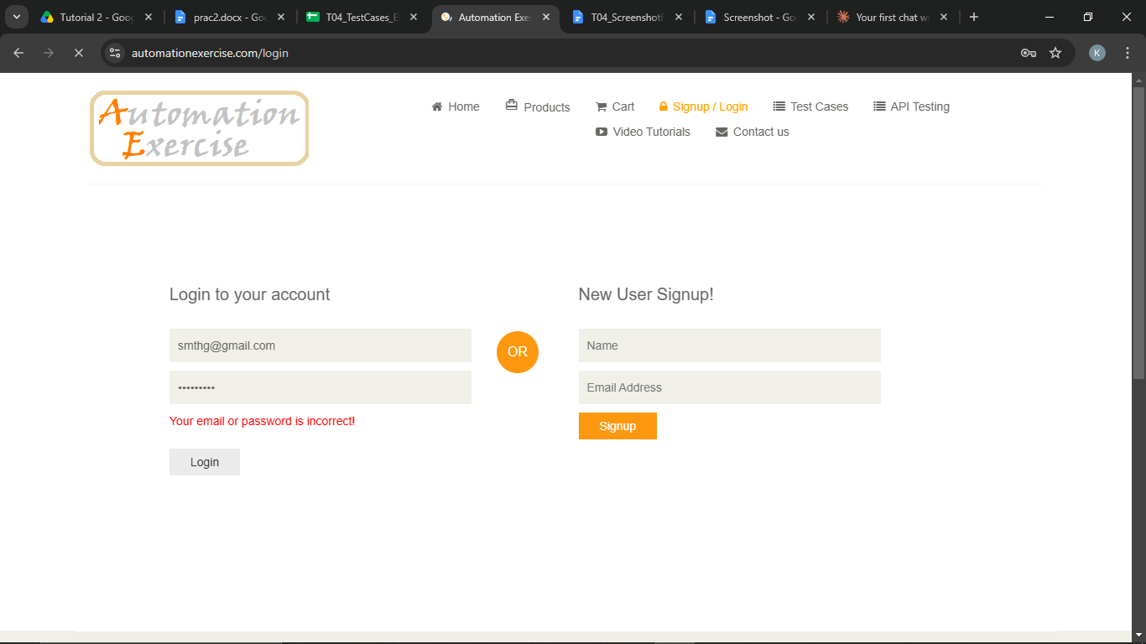
Defect ID | N/A

TC04 – Verify login when both email and password are invalid
TC ID | TC04
Test Case | Verify login when both email and password are invalid
Test Data | Email: abc@xyz.com; Password: 12345
Expected Result | Error 'Your email or password is incorrect!' is displayed
Actual Result | Error message displayed
Status | PASS
Screenshot | 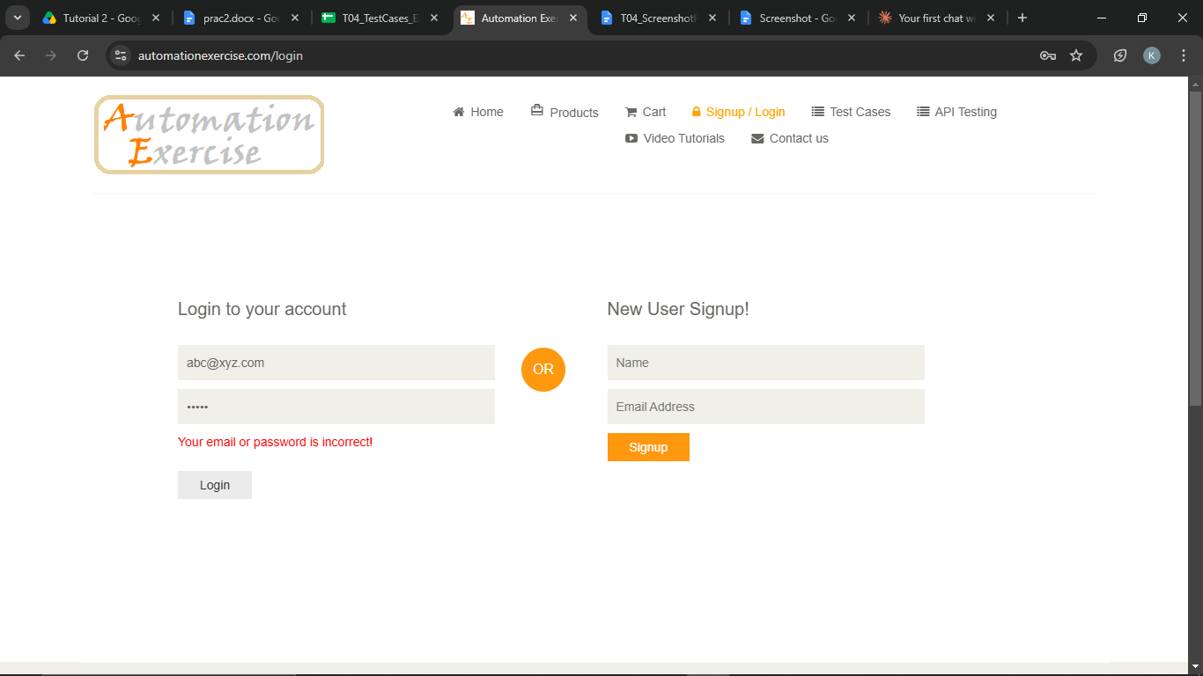
Defect ID | N/A

TC05 – Verify login with a blank email
TC ID | TC05
Test Case | Verify login with a blank email
Test Data | Email: (blank); Password: Test@1234
Expected Result | Validation message 'Please fill out this field.' is shown; login blocked
Actual Result | Validation tooltip shown
Status | PASS
Screenshot | 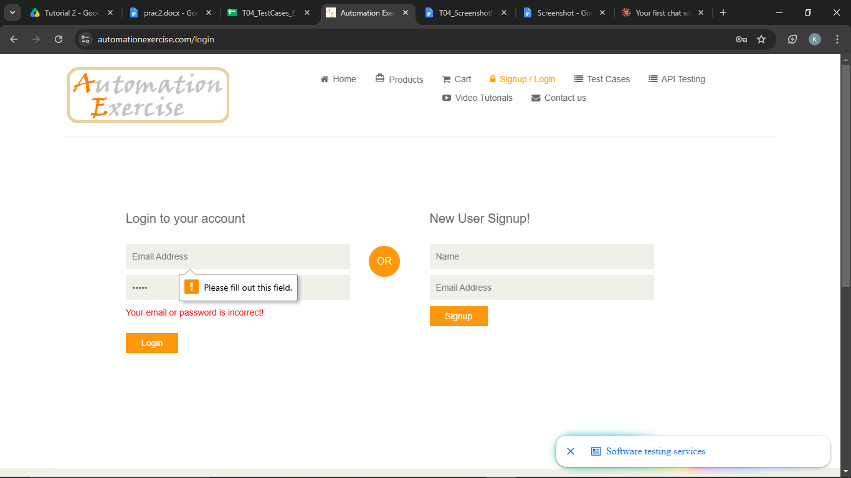
Defect ID | N/A

TC06 – Verify login with a blank password
TC ID | TC06
Test Case | Verify login with a blank password
Test Data | Email: <registered email>; Password: (blank)
Expected Result | Validation message 'Please fill out this field.' is shown; login blocked
Actual Result | Validation tooltip shown
Status | PASS
Screenshot | 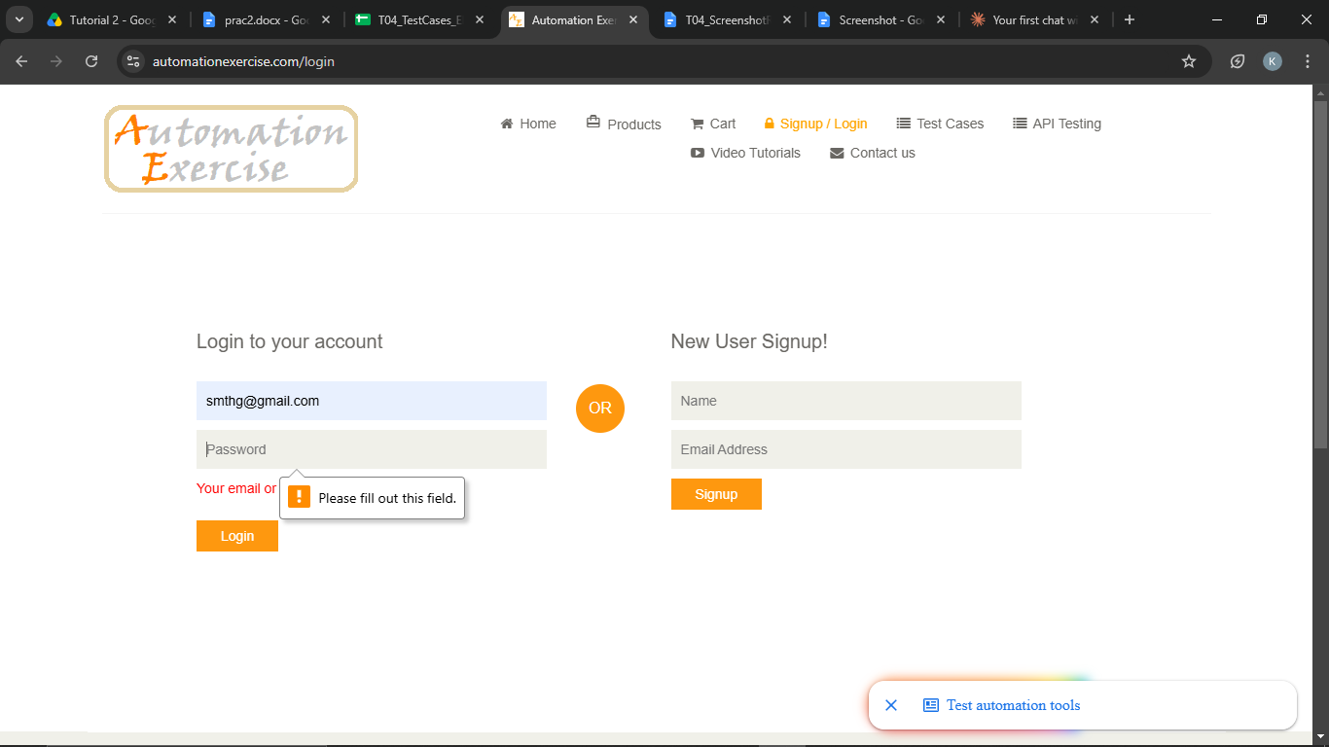
Defect ID | N/A

TC07 – Verify login with both fields blank
TC ID | TC07
Test Case | Verify login with both fields blank
Test Data | Email: (blank); Password: (blank)
Expected Result | Validation message is shown on the first empty field; login blocked
Actual Result | Validation tooltip shown
Status | PASS
Screenshot | 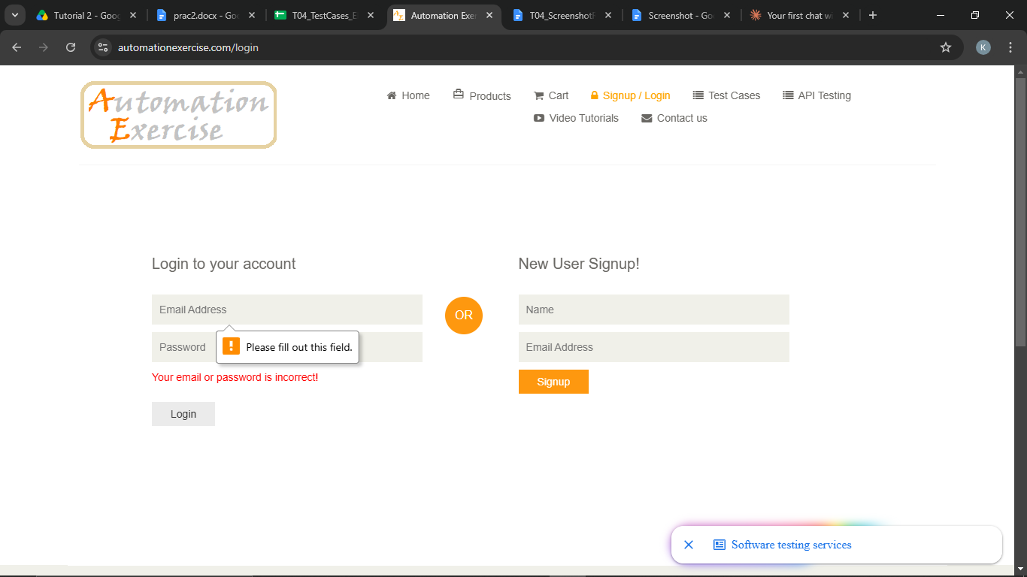
Defect ID

TC08 – Verify browser compatibility
TC ID | TC08
Test Case | Verify browser compatibility
Test Data | Browsers: Chrome, Edge/Firefox
Expected Result | Login page and login work the same in both browsers
Actual Result | Login page working on edge browser
Status | PASS
Screenshot | 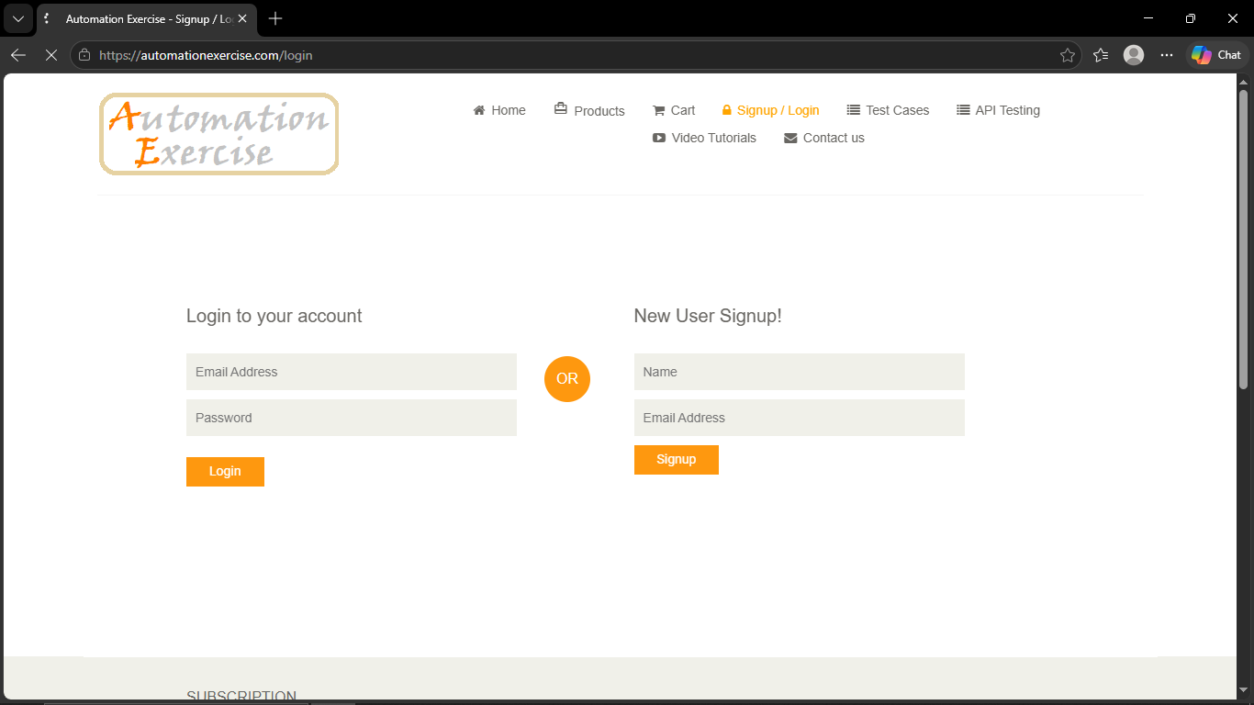
Defect ID

TC09 – Verify usability of the login page
TC ID | TC09
Test Case | Verify usability of the login page
Test Data | Browsers: Chrome
Expected Result | Fields are clearly labelled, messages are clear and the Tab order is logical
Actual Result | The login Page shows error on incorrect input
Status | PASS
Screenshot | 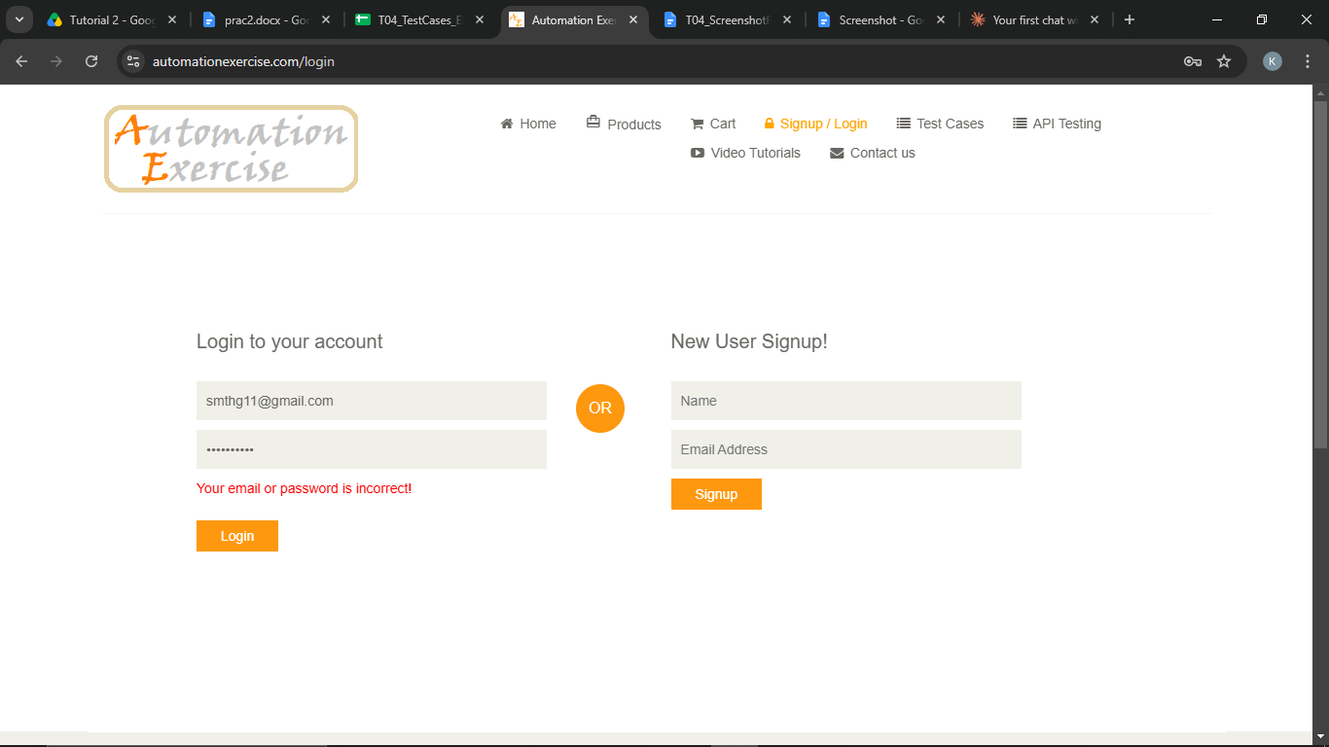
Defect ID | N/A

TC10 – Verify page layout of the login page
TC ID | TC10
Test Case | Verify page layout of the login page
Test Data | Window width: full and ~500 px
Expected Result | Elements are aligned, nothing overlaps and the layout adapts to the smaller window
Actual Result | The login page is properly aligned with proper elements
Status | PASS
Screenshot | 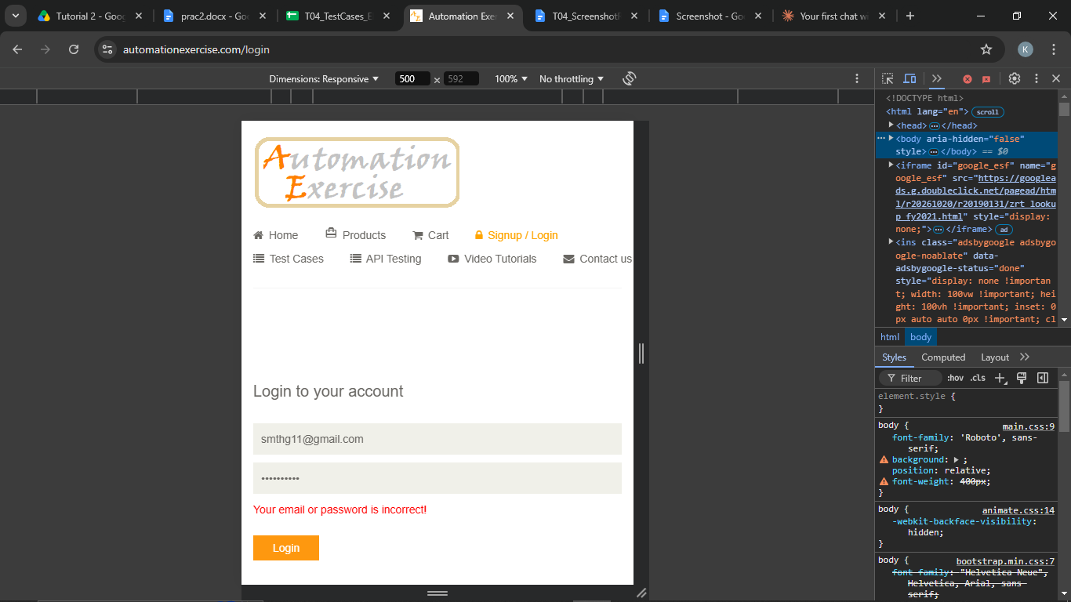
Defect ID | N/A

Test Execution Summary
Metric | Value
Total Test Cases | 10
Passed | 7
Failed | 0
Blocked | 0
Not executed yet (fill after running) | 3
Pass % | 100.0%

Counts are based on the draft statuses above; update them after you confirm each result.

